Table of Contents
1 Chapter : Introduction 2
1.1 Problem Definition 3
1.2 Motivation 4
1.3 Aims and Objectives 5
1.4 Scope 6
2 Chapter : Background 8
2.1 Literature Review 10
2.1.1 Open wireless sensor network telemetry platform for mobile phones 10
2.1.2 Sensor network to Android platform to control Rovio Robot 11
2.1.3 Location and Mobility in a Sensor Network of Mobile Phones 12
2.1.4 Conclusion 12
3 Chapter : Requirement Analysis & Design 13
3.1 Requirement Analysis 13
3.1.1 Functional Requirements 13
3.1.2 Non-Functional Requirements 14
3.2 Design 14
3.2.1 Proposed Solution 15
4 Chapter : Project Plan & Progress 16
4.1 Project Plan 16
4.1.1 Work Breakdown Structure 16
4.2 Progress 18
5 References 19
6 Web References 19

List of Tables

Table 4.1 : Project Plan.............................................................................................................17

List of Figures

Fig 2.1: Structure of a typical sensor network......................................................................... 09
Fig 2.2 : Wireless sensor network gateway for transmitting data to nearby mobile
phones over a short-range radio link..........................................................................11

Chapter : Introduction

An ad-hoc or short-live network is the network of two or more mobile devices connected to each other without the help of intervening infrastructure. In contrast to a fixed wireless network, an ad-hoc network can be deployed in remote geographical locations and requires minimum setup and administration costs. Moreover, the integration of an ad-hoc network with a bigger network-such as the Internet-or a wireless infrastructure network increases the coverage area and application domain of the ad-hoc network. However, communication in an ad-hoc network between different hosts that are not directly linked is an issue not only for search and rescue operations, but also for educational, military and business purposes.

An ad-hoc network can be classified into two main types: mobile ad-hoc network and mobile ad-hoc sensors network. Unlike typical sensor networks, which communicate directly with the centralized controller, a mobile ad-hoc sensor network follows a broader sequence of operational scenarios, thus demanding a less complex setup procedure. A mobile ad-hoc sensor or hybrid ad-hoc network consists of a number of sensor spreads in a geographical area. Each sensor is capable of mobile communication and has some level of intelligence to process signals and to transmit data. In order to support routed communications between two mobile nodes, the routing protocol determines the node connectivity and routes packets accordingly. This makes a mobile ad-hoc sensor network highly adaptable so that it can be deployed in almost all environments.

The mobile ad-hoc sensor network is a new invention with long-term potential for transforming our daily lives. In mobile ad-hoc sensor networks, each host may be equipped with a variety of sensors that can be organized to detect different local events. Moreover, an ad-hoc sensor network offers low setup and administration costs.

Problem Definition

Wireless ad-hoc sensor networks are very beneficial in different scenarios in different manner. These networks advance operational efficiency of certain civilian applications. [WWW03]

- Military sensor networks to detect and gain as much information as possible about enemy movements, explosions, and other phenomena of interest.
- Sensor networks to detect and characterize Chemical, Biological, Radiological, Nuclear, and Explosive attacks and material.
- Sensor networks to detect and monitor environmental changes in plains, forests, oceans, etc.
- Wireless traffic sensor networks to monitor vehicle traffic on highways or in congested parts of a city.
- Wireless surveillance sensor networks for providing security in shopping malls, parking garages, and other facilities.
- Wireless parking lot sensor networks to determine which spots are occupied and which are free.

Even though sensor networks are so important and useful there are some drawbacks wrapped with it, which will restrict the usage.
- Need to deploy hundreds of node
In order to collect accurate and efficient data it is necessary to deploy lots of sensor node on the selected geographical locations
- Considerable amount of initial cost
Usually single sensor node with generic sensors cost about hundreds of dollars. Therefore it will cost huge amount of initial cost since it is necessary to deploy lot of sensor.
- Power constraints
Those node are battery powered. And they can only be active for limited hours of time before battery drained. After that we will have to recharge each and every individual node.
- Communication constraints
Since those are low powered devices communication need to be done on very carefully without wasting more power. But anyway it need to necessary information over to the base station.
- Security complexities
- Node tracking issues
If we made those nodes mobile, then we need to have proper way of tracking their location.

Therefore even though we are using sensor networks a lot, there are many drawbacks that we need to take into consideration before going for it.

Motivation

Ad-Hoc wireless sensor networks are becoming an important part of the technology. Its already been using in different scenarios to save lives. And the basic goals of using a wireless ad hoc sensor network generally depend upon the application, but the following facts are the most common motivative to use sensor networks.
- Determine the value of some parameter at a given location: In an environmental network, one might one to know the temperature, atmospheric pressure, amount of sunlight, and the relative humidity at a number of locations. This example shows that a given sensor node may be connected to different types of sensors, each with a different sampling rate and range of allowed values.
- Detect the occurrence of events of interest and estimate parameters of the detected event or events: In the traffic sensor network, one would like to detect a vehicle moving through an intersection and estimate the speed and direction of the vehicle.
- Classify a detected object: Is a vehicle in a traffic sensor network a car, a mini-van, a light truck, a bus, etc.
- Track an object: In a military sensor network, track an enemy tank as it moves through the geographic area covered by the network.

The rise of powerful mobile phone platforms like Android and iOS introduces an escape from some of these problems that are bundle with sensor networks.
- Mobile phone platforms tend to be widely available, as economies of scale drive their prices down.
- Their hardware and software systems are much more homogeneous in nature than sensor network architectures as a whole.
- They have built-in support for a number of sensor needs, such as cameras and cellular radios.
- Because these devices are broadly used for personal consumption, they provide a sense of immediate availability not seen in traditional embedded systems.

Therefore there are lots of sensor networks deployed all around the world for different purposes. Even though there are many drawbacks as well. And if we can find some alternatives to avoid those drawbacks, we can gain the maximum use from this sensor network concepts. After this has been implemented everyone can use this network to collect the relevant magnetic fields data from any geological location as they expected. Hence we can save lot of funds and effort by avoid implementing new sensor network from the scratch. And going forward if we can create a trend to use mobile phone as sensor node then more sensors will introduced into upcoming smart phones and that will make this concept more useful and expandable in future.

Aims and Objectives

Therefore as its explained above the main objective of this is to find a way to avoid the drawbacks of the ad-hoc sensor networks that will be by emulating sensor network using mobile phone. And following are the other objectives of this,
- Find an appropriate media to communicate with other nodes. There are many alternatives like bluetooth, infared, wifi, and mobile data connection. This can use different mediums depending on the situation.
- Model communication hierarchy of the sensor network that is how a single node shares information with its base station and how that base station can send all the collected data to the single centralized location. And how frequently it should upload those data. When deciding those factors it is necessary to consider low power, low memory. Low processing and other constraint on those sensor nodes.
- Elaborate the importance of this by using an innovative application to one of the major Smart phone platform. After take the all smart phone platforms in to consideration it is decided that android is the best suitable platform for this prototype implementation.
- User evaluation to measure the importance of this solution. This will ensure that findings of this effort are useful to the society.

Scope

- There are many mediums to communicate on mobile phones. Like Wifi, Bluetooth, Mobile data connection. Therefore it is necessary to find what the best medium to serve the purpose.
- Need to model the communication hierarchy. This will be the baseline for communication between node-node and node-base station. This should align with the communication medium selected above.
- Once best communication medium and communication hierarchy defined, a solid architecture design needed upon implementing the application.
- Implement the innovative application on one of the smart phone platforms, to demonstrate the importance.
- Using implemented application user can specify the type of information he needs, the frequency and around which location, based on GPS locations.
- Need to find method to find the closest nodes to given GPS location.
- User will have GUI, as well as a command base interface for advance users to query the necessary information.
- Implement a policy that a user will receive data as a proportion to their contribution to others to gather their information. That will keep everyone contribute to the community.

This is the basic introduction to the problem, aims and objectives of the project. The next chapter will describe the background on ad-hoc sensor networks, Android platform and literature review of the problem. And it describes the other solutions proposed, and developed for this problem and how far are they successful in solving this problem.

Then the third chapter briefly describe the functional and non-functional requirements that need to satisfied in order to address this problem. And the the communication methodology and architecture of the proposed solution is described in detail on this chapter.

The final and fourth chapter described the work plan and work breakdown structure for the project. And also it includes how far it achieved and is this feasible on the existing time line. The issues raised, work done and remaining tasks to be done are also explains on the fourth and final chapter.

Chapter : Background

Although wireless sensor nodes have existed for decades and used for applications as diverse as earthquake measurements to warfare, the modern development of small sensor nodes dates back to the 1998 “Smartdust” project and the NASA Sensor Webs Project. One of the objectives of the “Smartdust” project was to create autonomous sensing and communication within a cubic millimeter of space. Though this project ended early on, it led to many more research projects. The researchers involved in these projects coined the term mote to refer to a sensor node. The equivalent term in the NASA Sensor Webs Project for a physical sensor node is pod, although the sensor node in a Sensor Web can be another Sensor Web itself. Physical sensor nodes have been able to increase their capability in conjunction with Moore's Law. The chip footprint contains more complex and lower powered micro controllers. Thus, for the same node footprint, more silicon capability can be packed into it. Nowadays, motes focus on providing the longest wireless range, the lowest energy consumption and the easiest development process for the user. [WWW05]
The WSN is built of "nodes", from a few to several hundreds or even thousands, where each node is connected to one or more sensors. Each such sensor network node has typically several parts: a radio transceiver with an internal antenna or connection to an external antenna, a micro controller, an electronic circuit for interfacing with the sensors and an energy source, usually a battery or an embedded form of energy harvesting. A sensor node might vary in size from that of a shoe box down to the size of a grain of dust, although functioning "motes" of genuine microscopic dimensions have yet to be created. The cost of sensor nodes is similarly variable, ranging from hundreds of dollars to a few pennies, depending on the complexity of the individual sensor nodes. Size and cost constraints on sensor nodes result in corresponding constraints on resources such as energy, memory, computational speed and communications bandwidth. The topology of the WSNs can vary from a simple star network to an advanced multi-hop wireless mesh network. The propagation technique between the hops of the network can be routing or flooding.

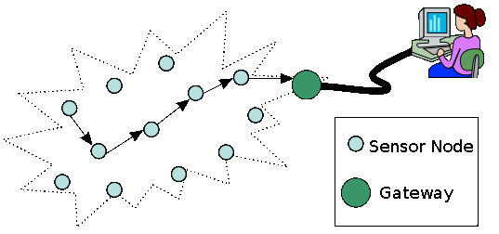
Fig 2.1: Structure of a typical sensor network

Some of the Wireless ad hoc sensor network characteristics are as follows,
Large number of sensors: Aside from the deployment of sensors on the ocean surface or the use of mobile, unmanned, robotic sensors in military operations, most nodes in a smart sensor network are stationary. Networks of 10,000 or even 100,000 nodes are envisioned, so scalability is a major issue.
Low energy use: Since in many applications the sensor nodes will be placed in a remote area, service of a node may not be possible. In this case, the lifetime of a node may be determined by the battery life, thereby requiring the minimization of energy expenditure.
Network self-organization: Given the large number of nodes and their potential placement in hostile locations, it is essential that the network be able to self-organize; manual configuration is not feasible. Moreover, nodes may fail, and new nodes may join the network. Therefore, the network must be able to periodically reconfigure itself so that it can continue to function. Individual nodes may become disconnected from the rest of the network, but a high degree of connectivity must be maintained.
Collaborative signal processing: Yet another factor that distinguishes these networks from MANETs is that the end goal is detection/estimation of some events of interest, and not just communications. To improve the detection/estimation performance, it is often quite useful to fuse data from multiple sensors. This data fusion requires the transmission of data and control messages, and so it may put constraints on the network architecture.
Querying ability: A user may want to query an individual node or a group of nodes for information collected in the region. Depending on the amount of data fusion performed, it may not be feasible to transmit a large amount of the data across the network. Instead, various local sink nodes will collect the data from a given area and create summary messages. A query may be directed to the sink node nearest to the desired location.

Literature Review

Sensor network are been very helpful to the society throughout the last decade. Therefore many people try to avoid those drawback them to make maximum use of them. And make it less complicated for people who want to build up new sensor networks. In order to do so many people try to use public mobile phone to enhance the capabilities of sensor networks. Some of those efforts are described below.

Open wireless sensor network telemetry platform for mobile phones

Mobile phones are an underutilized resource for connecting low-power wireless sensor networks to the Internet. WSNs typically expend most of their battery power on data transmission. Mobile phones carried by the public could enable a hybrid approach where data makes a low-power short distance hop to phones in the vicinity using Bluetooth or a similar short range protocol, then uses the phones’ long distance connectivity to upload to the Internet. Because a large fraction of mobile phones have Bluetooth short-distance radio, this effort is to find low-cost hardware for a generic WSN-to-Bluetooth gateway and open-source software that allows a wide subset of mobile phones to download and save WSN data.
This concept was proposed by C. K. Harnett and his effort is to makes available an open-source “opportunistic telemetry” system that creates the long-distance data link using mobile phones carried near the sensor network, reducing the power burden on the WSN. The overall system is illustrated in Fig 2.2 below.
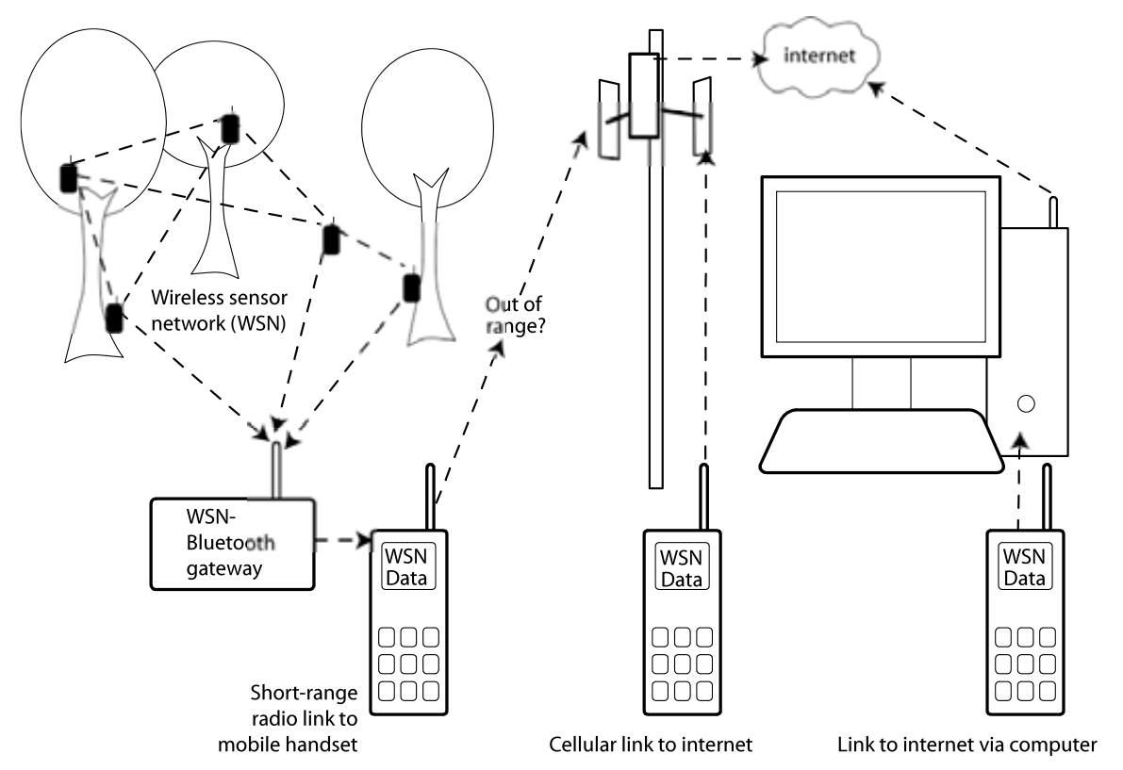
Fig 2.2 : Wireless sensor network gateway for transmitting data to nearby mobile phones over a short-range radio link

Sensor network to Android platform to control Rovio Robot

This effort was done by Yusuf Simonson, Robert Fowler at Renaissance Computing Institute and Edgar Lobatón at The University of North Carolina.
They believe that new smart phone architectures like Android and iOS will play increasingly important roles in sensor network design. Because of this, they wish to investigate the state of development for sensor network-based applications on the Android framework. They introduce an application for Android that allows for the semi-autonomous remote control of Rovio robots. It coordinates with a sensor network of cameras to provide a live stream of camera images and predicted robot locations. Furthermore, it provides functionality for moving the robot to user-selected destinations without the need for manual control. The application acts as a straw man for working with traditional sensor network architectures, and provides important insight on some of the challenges related to sensor network development, especially on the Android platform. They outline these challenges and provide some suggestions on semantics that could alleviate development effort.

Location and Mobility in a Sensor Network of Mobile Phones

This research was done by Aman Kansal and Feng Zhao at Microsoft Research center.

Mobile phones have two sensors: a camera and a microphone. Their goal in this position paper it to explore the use of these sensors for building an audio-visual sensor network that exploits the deployed base of millions of mobile phones worldwide. Among the several salient features of such a sensor network, we focus on mobility. Mobility is advantageous since it yields significant advantage in spatial coverage. However, due to the uncontrolled nature of device motion, it is difficult to sample a required region with a given device. They propose a data centric abstraction to deal with this difficulty. Rather than treating the physical devices as their sensor nodes, they introduce a layer of static virtual sensor nodes corresponding to the sampled data locations. The virtual nodes corresponding to the required region to be sensed can be queried directly to obtain data samples for that region. They discuss how the locations of the virtual sensor nodes can be enhanced, and sometimes derived, using the visual data content itself. Experiments with real data are presented to expose some of the practical considerations for their design approach.

Conclusion

I believe smart phones or platforms with similar capabilities will play an increasingly prevalent role in sensor network architectures given their commodity pricing and rich sensing hardware. And with their increasing capabilities can used in more meaningful manner to build up simple but useful sensor network.
All above mentioned solutions are working in some way and tried to address some of the drawback appear on sensor networks. But there are more areas to cover in this aspect.

Chapter : Requirement Analysis & Design

Detail requirements need to be identified and analyze before going into designing the solution. Therefore following chapter describe the requirement analysis and the design to the problem described above chapters.

Requirement Analysis

Even though we have used sensor networks for quite a some time still there are lots areas that we can improve to make the better use of it. This effort is also to reduce the drawbacks of sensor network using public mobile phones as sensor motes. As I consider the most of the smart phone platforms, Android seems to be the best suitable platform for this purpose. That will avoid many difficulties that were with traditional motes. And this must not interfere with usual mobile phone usage of the user.
The prototype applications functional and non-functional requirements are as listed below.

Functional Requirements

- Application need to be using the communication model defined at the modeling stage. That is to use bluetooth to communicate with all the close by nodes and collect those data into one randomly selected node with in a defined time period. And at the end of that time upload all the data to the centralized location using long distance data connection. This will be the data connection of that mobile phone.
- Once user start the application this should be run on the background until the user forcefully stops it. Until that it will collect, communicate and upload data as requested.
- Anyone of who is running the application will be a user as well as a contributer of the sensor network. And it will always send data as per others requirements. But if a user need to collect data then he can run a query to collect data as his requirement. Then as for your query it will upload data.
- There should be a GUI to set his preferences and query data. And a command line interface is also so there for advance users.
- Current implementation will be only for magnetic field sensor. But this can be further enhance to use lot of other sensors available for on those devices.

Non-Functional Requirements

- Application need to be use the sensor and the battery optimum way. Otherwise it will leads to drain the mobile phones battery very quickly.
- Since this is running on the background this should not effect the normal usage of the mobile phone. Simply this should not disturb users activities.
- Sensor network integration need to be done seamlessly that the mobile phone user should not feel that there is running some other sensor application on his mobile phone.

Design

After consider all the smart phone platforms into consideration it is decided that android is the best suitable platform to implement this concept. Android was selected as for the following facts,
- Free and open source platform anyone can get the source and change.
- Most popular smart phone platform for the last couple of years and therefore there are lot of phone distributed all over the world.
- Eclipse integrated SDK is freely available for application developers on android. It makes the implementation a quite simple.
- There is experienced community to get support from.
- It doesn't need specific hardware to do the implementation.

The main objective of this is to emulate a sensor network using mobile phones. In this context a mobile phone will be just a sensor mote which can play the traditional sensor motes role. Therefore once the prototype application implemented with the above specified requirements anyone using this application can collect relevant sensor information. Once user specified the location and the time frequency of the data he needs, the application will search his network to find out the devices close to that location. For this it will use the devices in build GPS sensor. And after it located the close by nodes it will create a logical network for that specific request. Then that network will collect those data necessary for the user. With in that network all the nodes will communicate using in built bluetooth or wifi sensors. And transfer all the data to few selected nodes. And those those node will upload the data into the centralized location. Using this method every node does not need to upload data which will be consuming lot of battery power.

Proposed Solution

As described in the literature review there are many people who tried to involve mobile phones with sensor networks. But still there are lot areas to cover in order to improve the sensor network efficiency.
Therefore my effort here is to use public mobile phones as sensor network. That is mobile phone can collect, communicate and upload data to the centralized location. But we can not do this task using factory mobile alone. We need some sort of application to manage node communication, data transfers user queries and everything. Thats why we need a simple application and that is where we selected android to implement the application on. And once user queries the data mobile phone will collect those data and upload those data into the centralized location where he can access. Therefore in this approach we do not need any more expensive sensor node to do this task. And also deploying an such a sensor network is a huge task which take lot of effort, time and money. Therefore using this approach can build a sensor network with lesser effort but with same capabilities as usual traditional sensor network.

Chapter : Project Plan & Progress

Project Plan

Time duration for this project is about one year or 300 hours of time. Therefore we need to manage time very well to achieve expected target on this time line. In order to manage project to achieve the target it is necessary to break down tasks into individual components and assign time for those and monitor whether they are achieved on the expected time. If not necessary action needed to be taken to mitigate the rick of project being delayed.

Work Breakdown Structure

- Set up Environment
- It will be convenient to work on Linux when dealing with open source. There for Ubuntu will be the host OS.
- Setup SDK for the relevant mobile platform.
- Setup debugging tools like DDMS.
- Eclipse as the Integrated Development Environment.
- Setup environment to deploy and debug on real device.
- Find out the best communication media to reach others
    - Check with every possible media
    - Do a analysis to choose the best suitable media
- Model the Sensor network
    - How to communicate with each other, which is communication hierarchy.
    - How to send collected data to base station.
    - Overall view of the sensor network.
- Design demonstrative application
- Choose the platform version.
- Design the core functionality
- Design GUI
- Implement the application
- Implement the core functionality.
- With core advance user will be able to work on command line to get the functionality to work.
- Implement the GUI, where any ordinary user can use the application to get information need.
- Follow the Google coding standard
    - Consistent throughout the code.
- Tesing
    - Test functionality and GUI works as expected using emulator.
    - Deploy on real device and test for compatibility.
    - User evaluation.
- Share outputs and sample application on repository where everyone can access.

And work plan for the above task and to complete the project on the given time is as follows,

Task | January | February | March | April | May | June | July | August | September | October | November | December
Project Proposal
Setting up Environment
Most suitable comm. Media
Model the sensor network
Design the demonstrative application
Implement core functionality of application
Prepare the Interim report
GUI design and implementation
Policy to trust and gain information
Testing on emulator and on a real device
Following Google coding standard
User evaluation
Fine Tuning
Prepare Dissertation
Table 4.1: Project Plan

Progress

Currently its on schedule with the initial project plan above. According to the plan I have completed the first 3 tasks. And currently working on the design and the communication model. And also I was able implement simple application on android to access the sensor API and use those data from the application.
Because of seasonal holidays on April it went little away from the initial plan. But these days I'm catching up those losses and I think currently I'm on schedule with the initial plan.

References

Xiang-Yang Li (2008). Wireless Ad Hoc and Sensor Networks: Theory and Applications, First Edition, Cambridge University Press, ISBN 0521865239.
Cordeiro, C.D.M. & Agrawal, D.P. (2006). Ad Hoc & Sensor Networks: Theory and Applications, First Edition, World Scientific Publishing Company, ISBN 9812566821.
Ableson, F., Collins, C. & Sen, R. (2009). Unlocking Android: A Developer's Guide, First Edition, Manning Publications, ISBN 1933988673.
Burnette, E. (2009). Hello, Android: Introducing Google's Mobile Development Platform, Second Edition, Pragmatic Bookshelf, ISBN 1934356492.
Hashimi, S.Y., Komatineni, S. & MacLean, D. (2010). Pro Android 2, First Edition, Apress, ISBN1430226595.

Web References

[WWW 01] http://en.wikipedia.org/wiki/Smartphone [12/02/2011]
[WWW 02] http://en.wikipedia.org/wiki/Wireless_sensor_network [12/02/2011]
[WWW 03] http://www.computingunplugged.com/issues/issue200410/00001398001.html [03/03/2011]
[WWW 04] http://www.sensor-networks.org/ [03/03/2011]
[WWW 05] http://en.wikipedia.org/wiki/Sensor_node [03/03/2011]

